High-Level Project Description

The Research Grant Status Tracker (RGST) is aimed to provide a quick, reliable, and easy to use interface that can display queried work order balances to authorized users. The current process of receiving a balance inquiry on a research grant takes unnecessary time for the requester and causes extra work for Ms. Jean Schroeder, USNA’s Grant Specialist, as she must manually process every request. This process is accomplished by a sequence of copy and pastes into an all-encompassing Microsoft Excel spreadsheet by Ms. Schroeder. Using the proposed RGST System that can be observed in Figure 1, Naval Academy staff will be able to personally query their own work orders’ and research grants’ balance and budget their projects accordingly from their accounts which will access the new database system that we will develop for Ms. Schroeder. Our team will be focused on producing the web-front for secure database access. Project specifications include fast, accurate, and confidential data transfer in an extremely navigable manner. Furthermore, we hope to ease Ms. Schroeder’s method of entering work orders by giving her administrative access to the website to which she may have read and write access to all applicable grant entries.

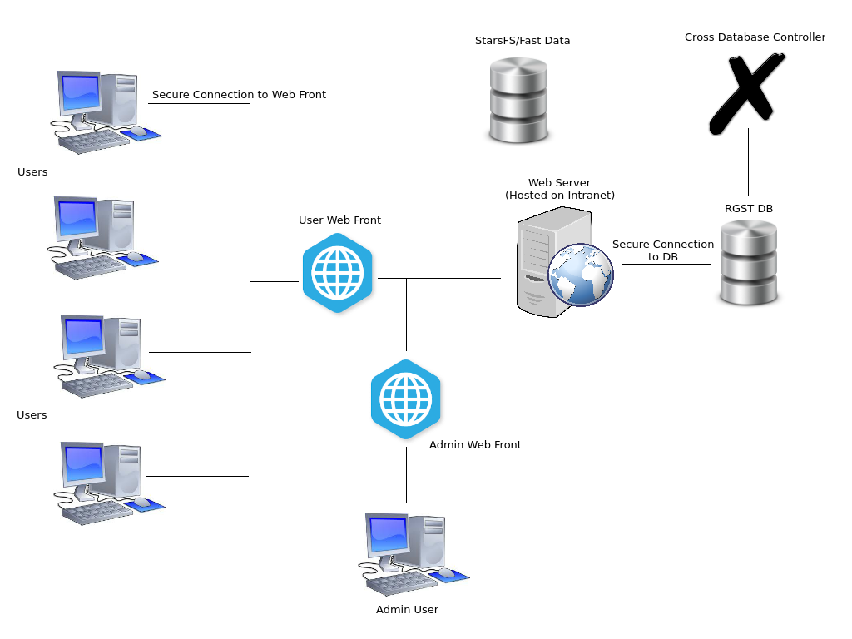

Figure 1. High Level View of the RGST